SouthWest University
School of Computer and Information Science

Program: Computer Science and Technology
Couse Title: Principle of Programming
Chapter Title: Control
Unit No: 02
Assignment No.: 01

Issue Date: 2021-11-18

Submission Deadline: 2020-11-30

Assessor/Tutor: Li Ya

Student: Cheng Yi

Student No.: 222021321102110

NOTES TO STUDENTS
- Carefully check the submission date and the instructions given with the assignment. Late assignments will not be accepted.
- If you are unable to hand in your assignment on time and have valid reasons such as illness, you may apply (in writing) for an extension.
- If you are caught plagiarizing, you could have your grade reduced to zero, or at worst, you could be excluded from the course.
- Your submission document should include screen shots of the Python IDLE showing your code and the output results of running your code.
- Complete your assignment in Word document and submit it to FTP server.
- Your file name should start with your Reg. No, and then include your name, and assignment NO. for example “222012321062259_李丹_assignment1.docx”. Remember to link different fields together using the underscore character (_).

Formatting Concerns
#1: You should have a header that explains the program
#2: There should be a space between the prompt and the place where you type in the value.
#3: Your work should be formatted nicely as in the sample output.

STUDENT’S DECLARATION:

I confirm that this is all my own work.

Student Signature:

Assignment Description
Scenario and Tasks：

1. Puzzle
A famous puzzle follows.
SEND
+ MORE
MONEY
Substitute each letter in the equation with a single integer 0-9 (no duplicates) such that the addition is correct. Write a program to solve this puzzle.
Hint: Brute force works well—try all possibilities.

Solution:

Code:
import sys

# Record whether the currently enumerated number is available (1 is available and 0 is not available)
tags = [1, 1, 1, 1, 1, 1, 1, 1, 1, 1]
# As to:0 1 2 3 4 5 6 7 8 9
letters = "SENDMORY"
num = [99, 99, 99, 99, 99, 99, 99, 99] # Store the replacement number for the letter

# Original: SEND + MORE = MONEY
# Position: 0123 4561 45217

def checkResult():
# Check that the populated numbers are available

# The three numbers in the current enumeration case
send = num[0]*1000 + num[1]*100 + num[2]*10 + num[3]
more = num[4]*1000 + num[5]*100 + num[6]*10 + num[1]
money = num[4]*10000 + num[5]*1000 + num[2]*100 + num[1]*10 + num[7]

# Judge that if the equation is established, print the results and exit the program
if send + more == money:
for i in range(len(letters)):
print('%s:%s;' % (letters[i], num[i]), end=' ')
print('\n-----------------')
print('%s + %s = %s' % ('SEND', 'MORE', 'MONEY'))
print('%s + %s = %s' % (send, more, money))
sys.exit()

def SetNumber(letterPos):
# Numerically fill the letter

if letterPos > 7: # Check to end, exit the program
return
for testNumber in range(10): # Test the number (0 to 9) availability for this letter
# Cannot equal the number of 0: s (position 0), m (position 4)
if testNumber == 0:
if letterPos == 0 or letterPos == 4:
continue

if tags[testNumber] == 1:
num[letterPos] = testNumber
tags[testNumber] = 0 # If the number tested has not been used, the letter is populated and marked as used

if letterPos == 7: # If the fill is complete, check for availability immediately
checkResult()

SetNumber(letterPos+1) # If nothing is checked out, continue to look for the next letter to correspond to the number
tags[testNumber] = 1 # Backtracking, the number is filled incorrectly and the number is relabeled available

SetNumber(0) # Check the number that the letter should fill in from the 0th bit

Screen Capture of The Code:
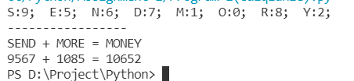

2. Weird multiplication

For this problem, you will be implementing the so-called Russian Peasant or Ancient Egyptian method for multiplication. It looks a little odd, but just think of it as an algorithm, a recipe for doing multiplication in a way other than what you learned in grade school.

The algorithm is as follows. If A and B are the two integers (only integers) to be multiplied, we repeatedly multiply A by 2 and divide B by 2, until B cannot be divided any further—that is, until its value becomes 0 (remember, this is integer division). During each step, whenever B is an odd number, we add the corresponding A value to the product we are generating. In the end, the sum of the A values that had corresponding odd B values is the product. Get it?

Here is an example:
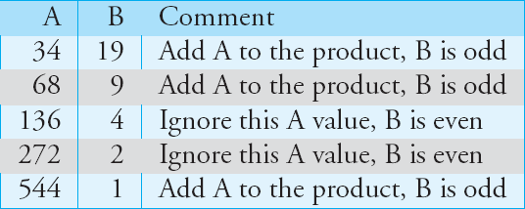

If the two integers to be multiplied are 34 and 19, the operations would be:
Sum up all the A values that had odd B values and you get: 34 + 68 + 544 = 646 => Final product.

(a) Part 1: Write a program to find the product of two integers.

(b) Part 2: Modify your program so that it repeatedly asks whether you want to find another product.

Solution:

Code:
- Part 1:
A, B = 34, 19
product = 0

while B:
if B % 2:
product += A
A *= 2
B //= 2
print('The product of two integers is:', product)

- Part 2:
print('Welcome to use this mini program. If you want to exit, just input the number 0.')
while True:
print('--------------------------------')
# Try to enter something, and if the input doesn't translate into an int type, you'll get an error
try:
A = int(input('Input your first number: '))
B = int(input('Input your second number: '))
except ValueError:
print('Invalid number. Please try again.')
continue
# The value of B is required to be positive
if B < 0:
print('Invalid number. Please try again.')
continue
# Exit the program scenario
if not A and B:
print('Exit successfully. Thanks for using.')
break

product = 0
while B:
if B % 2:
product += A
A *= 2
B //= 2
print('The product of two integers is: ', product)

Screen Capture of The Code:
- Part 1:
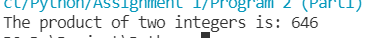

- Part 2:
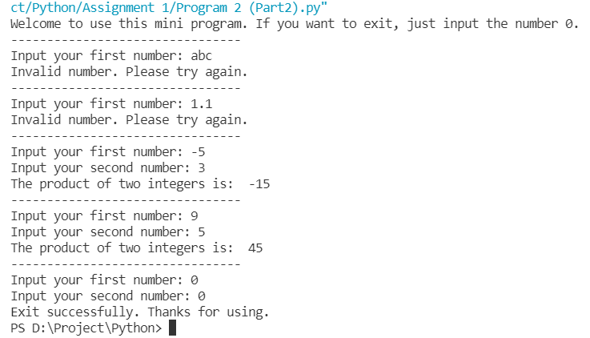

3. Calculate 7/911 to 1000 decimal digits after decimal point.

Solution:

Code:
import decimal

decimal.getcontext().prec = 1000
print(decimal.Decimal(7)/decimal.Decimal(911))

Screen Capture of The Code:
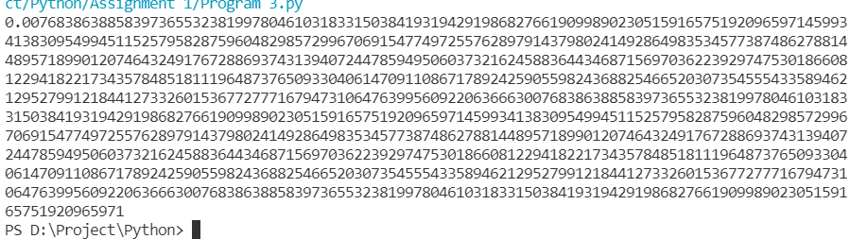

Assessor’s Signature
Date 2021-12-10

